Pig and Sqoop

**Part 1-Pig**

**1.Filter**





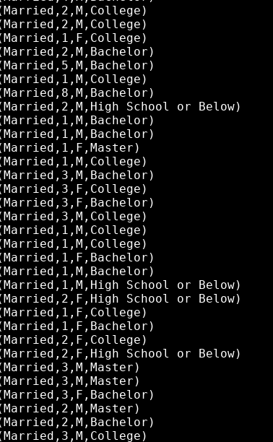

**2.Illustrate B;**

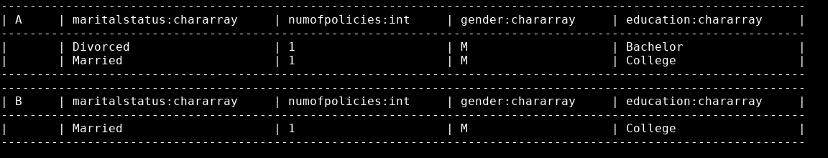

**3.Describe B;**

**4.For each**

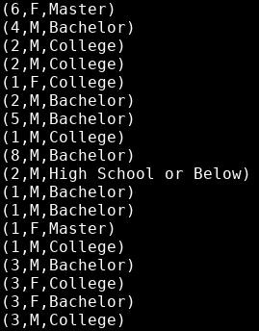

5.illustrate C;

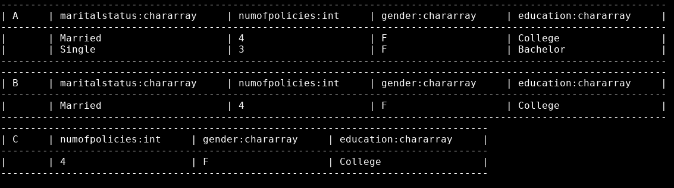

6.Store C into ‘/test_data/Data_married’;

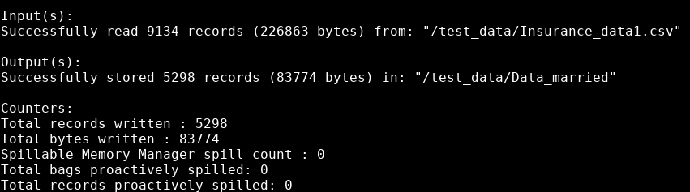

7.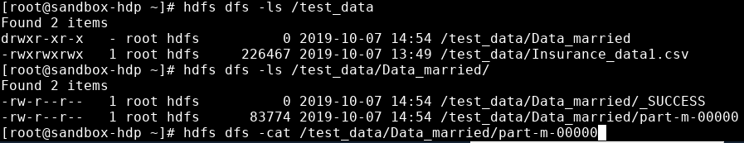



8.

Numofpolicies is not a primary key and hence there are duplicates.

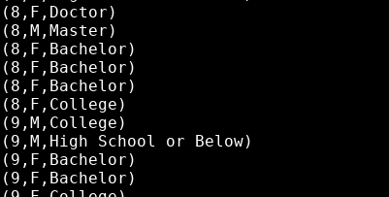

9.Startswith;

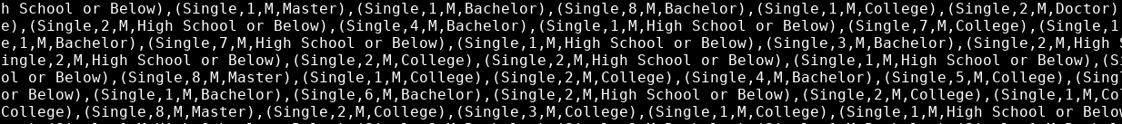10. Group bySinge male:

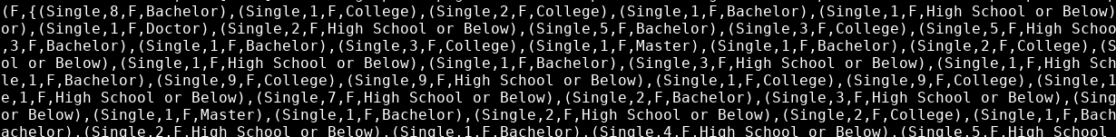Single Female:

11.

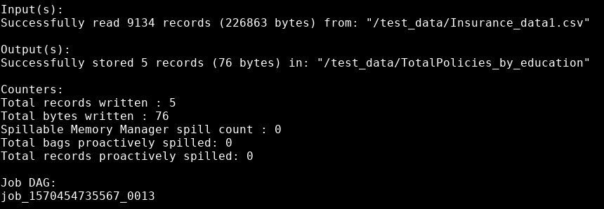

Illustrate D;

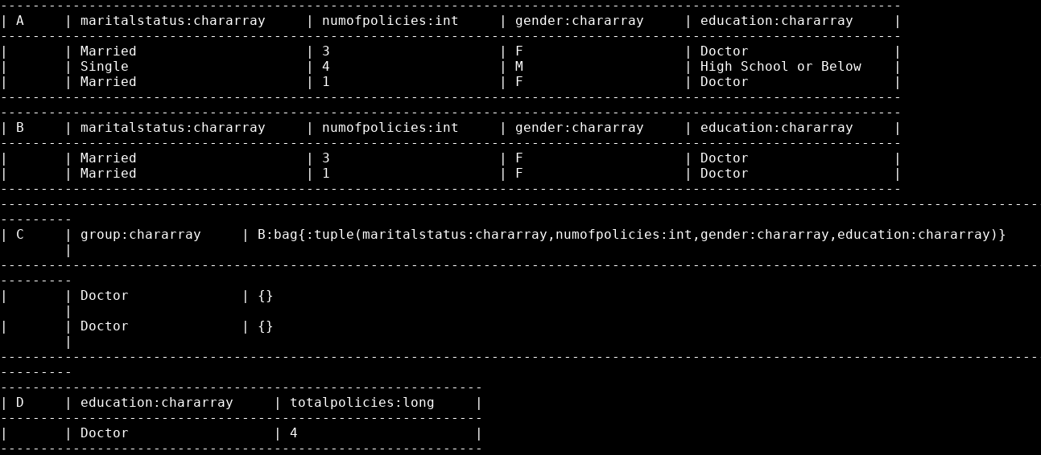

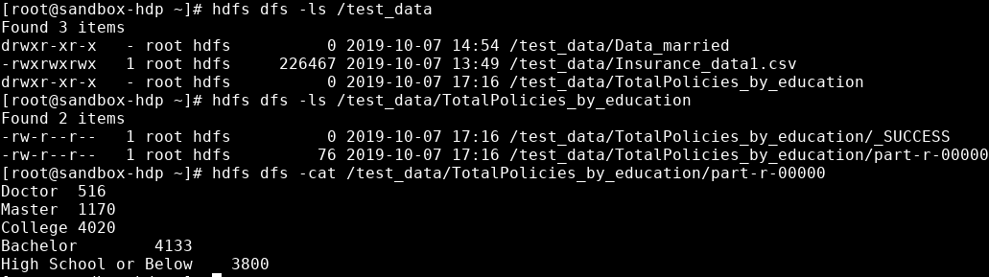

12. **DAG**

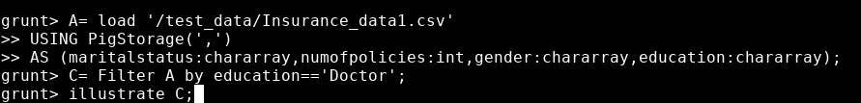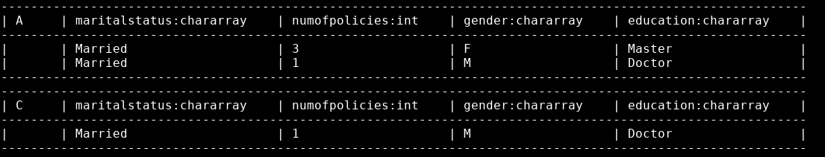

13.**SPLIT**

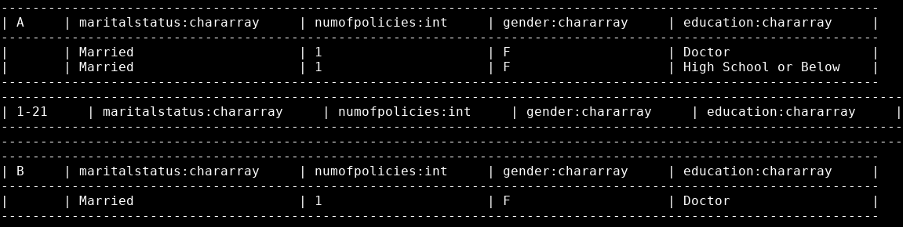

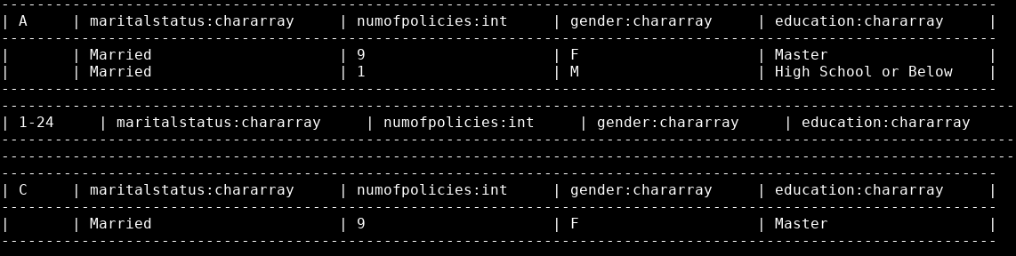

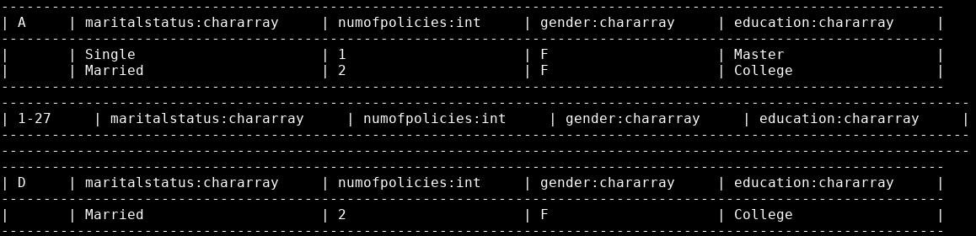

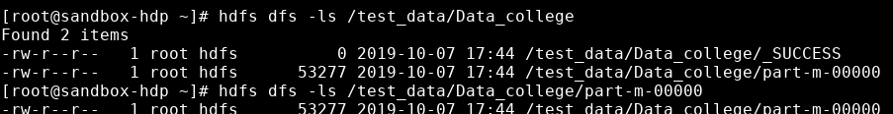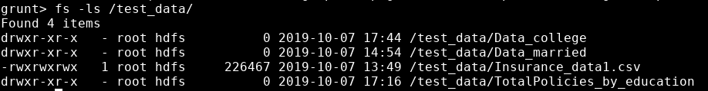14.

15**.FS**

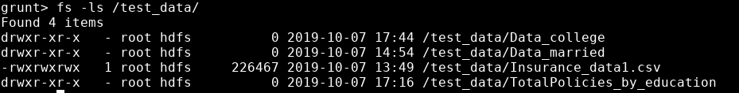

**Part 2-Sqoop**

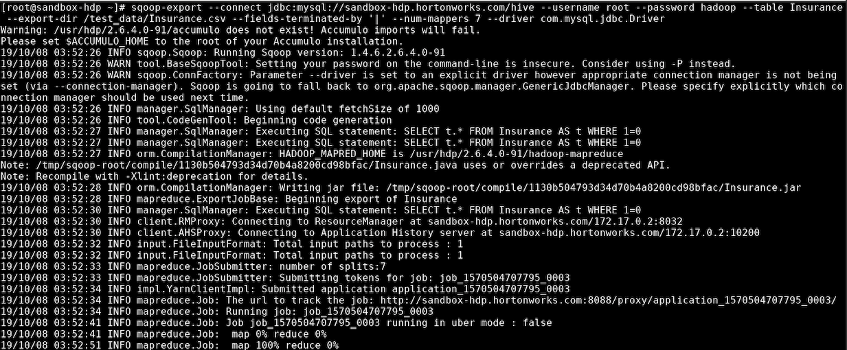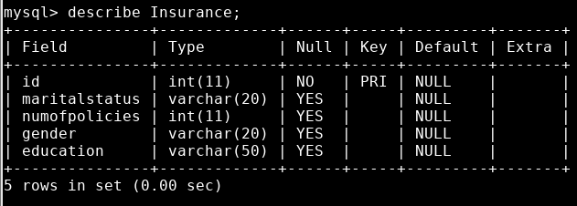Tried Sqoop export to learn to bring data from HDFS to MySQL. Creating a table Insurance in MySQL under hive database and exporting the insurance data in HDFS to the table in MySQL



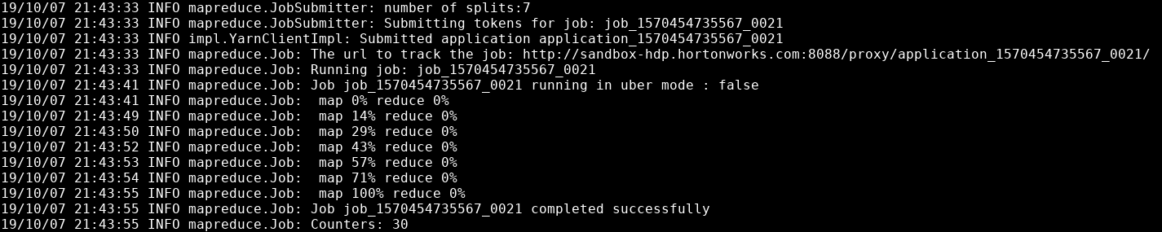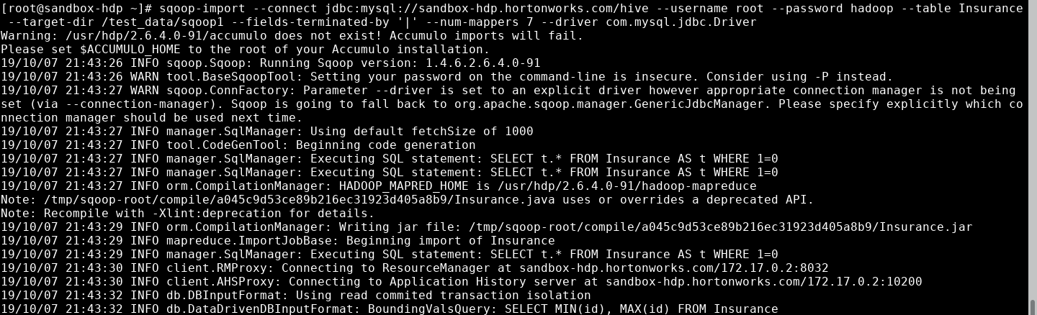**a. Importing table Insurance to HDFS location /test_data/sqoop1 with number of mappers 7**



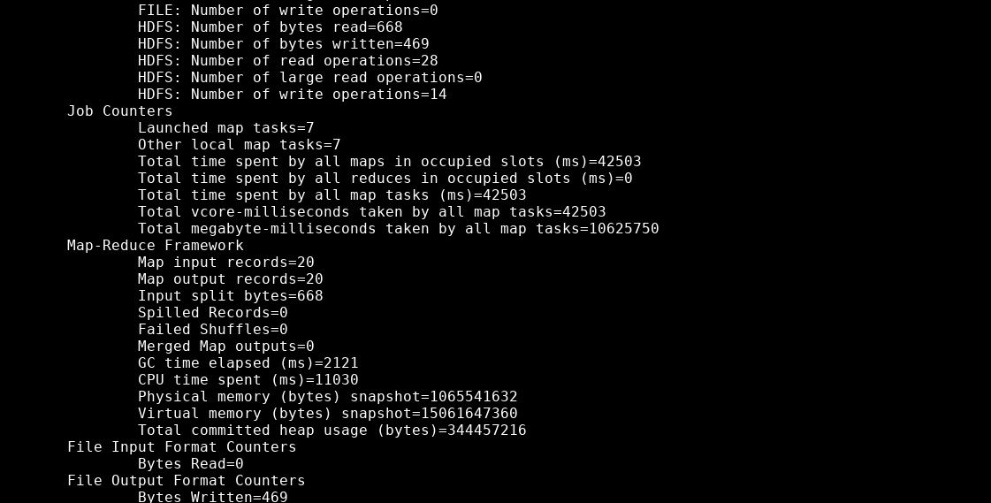



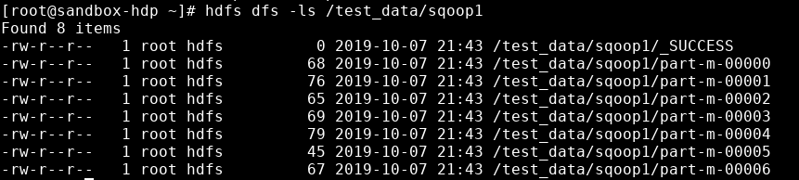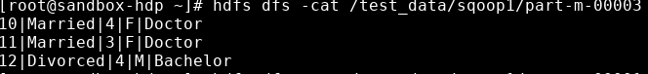

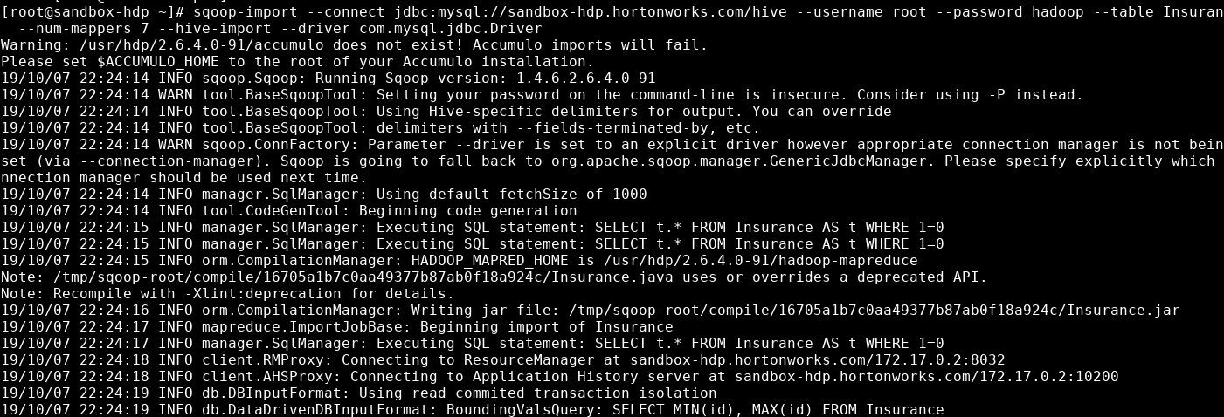**b. Using Sqoop to import Insurance table dataset to hive**



